# **Building a Flask Web Application**

**Project Objective:**

* To create a basic web application using Python's Flask framework.
* To demonstrate the fundamental concepts of web development with Flask.

**Project Scope:**

* Setting up the development environment
* Creating a Flask app
* Defining routes and view functions
* Handling user input with forms

**Project Definitions:**

**Web Application:** A software application that runs on a web server and can be accessed through a web browser. It typically consists of a client-side (browser) and a server-side component.

**Flask:** A lightweight Python framework for building web applications. It's known for its simplicity and flexibility, making it a great choice for beginners and experienced developers alike.

**Project Tasks:**

1. **Set up the Development Environment:**

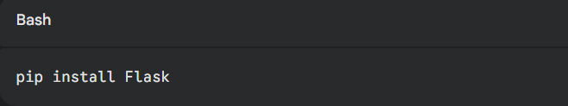

**2.Create a Basic Flask App:**

* Create a Python file (e.g., app.py).
* Import the Flask class:

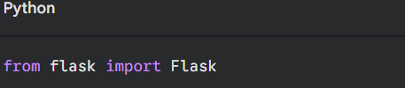

**a.Define a route and view function:**

Python

@app.route('/')

def hello_world():

return 'Hello, World!'

**b. Run the app:**

Bash

python app.py

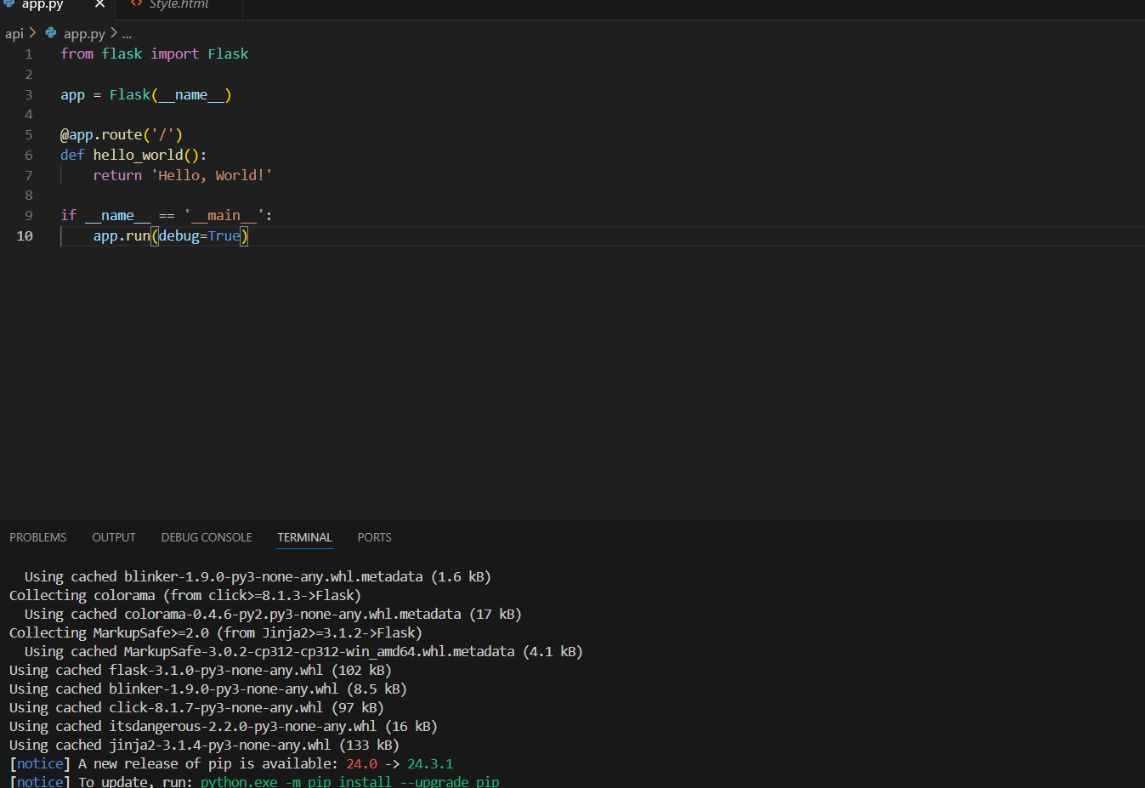**c.Render the template in the view function:**

**d.Handle form submissions in Flask:**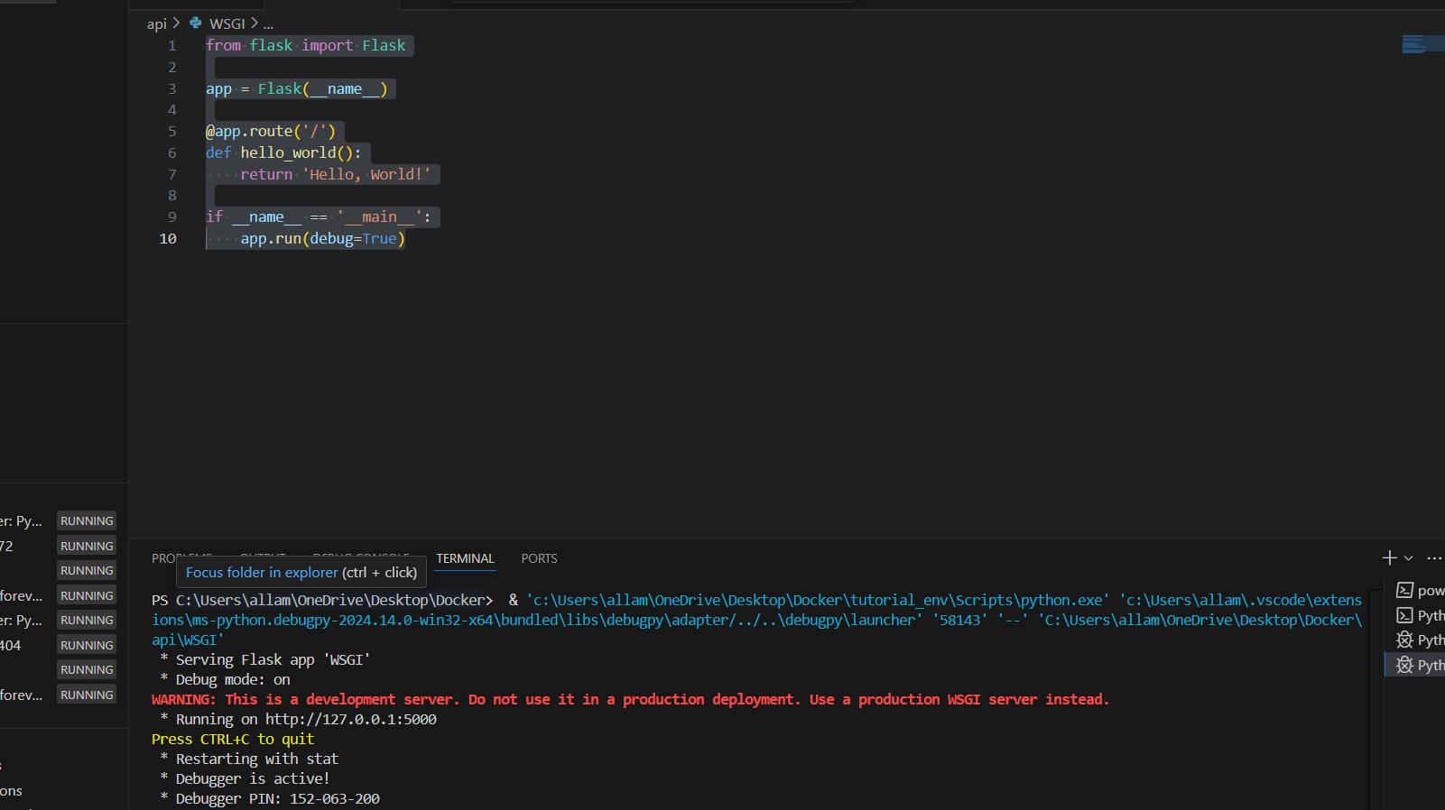

**Conclusion:** By following these steps, you can create dynamic and interactive web applications using Python's Flask framework.

1.Flask's simplicity and flexibility make it an excellent choice for both beginners and experienced developers. As you continue to explore Flask, consider delving into more advanced topics like database integration, user authentication, and deployment strategies to build robust and scalable web applications.